**PROJECT 6**

**Installing and Configuring Apache tomcat server on Linux**

1. Launching a LINUX Instance:

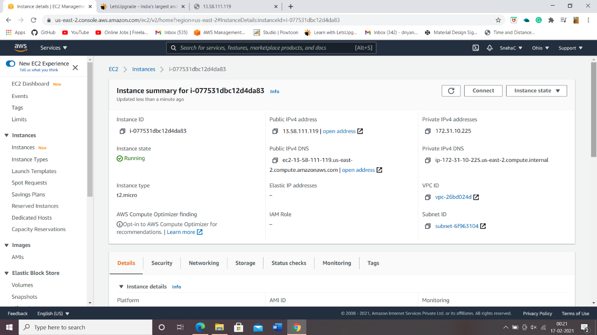

1. Installing Java 1.8 and Apache-tomcat:

* Using yum install java-1.8*command to install java.
* Using wget [https://mirrors.estointernet.in/apache/tomcat/tomcat-8/v8.5.61/bin/apache-tomcat-8.5.61.tar.gz & tar -zvxf apache-tomcat-8.5.61.tar.gz](https://mirrors.estointernet.in/apache/tomcat/tomcat-8/v8.5.61/bin/apache-tomcat-8.5.61.tar.gz%20&%20tar%20-zvxf%20apache-tomcat-8.5.61.tar.gz) command to install apache-tomcat server.
* Browsing some files and folder using ‘ls’ & ‘cd’ command.
* Now modifying permissions for startup.sh and shutdown.sh using chmod +x startup.sh & chmod +x shutdown.sh.
* Creating a softlink using ln -s path /usr/bin/tomcatup & ln -s path /usr/bin/tomcatdown.

1. Check whether Apache-Tomcat server is installed or not:

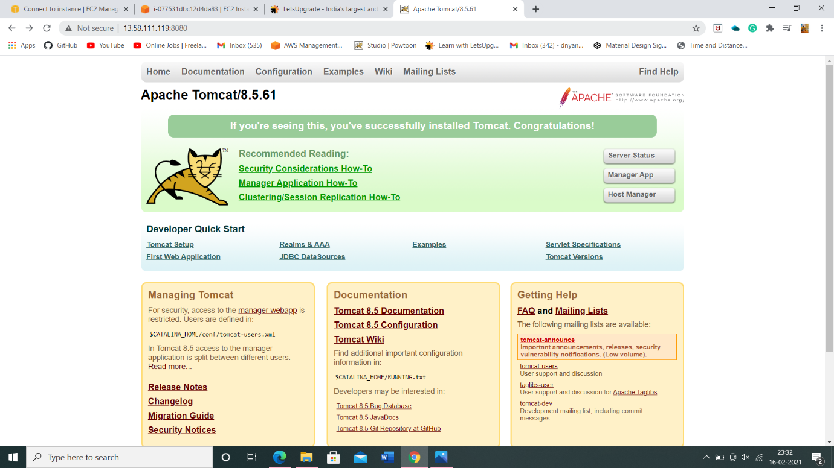

1. Changing the port to 8070 :

* Search for server.xml file and edit port number.

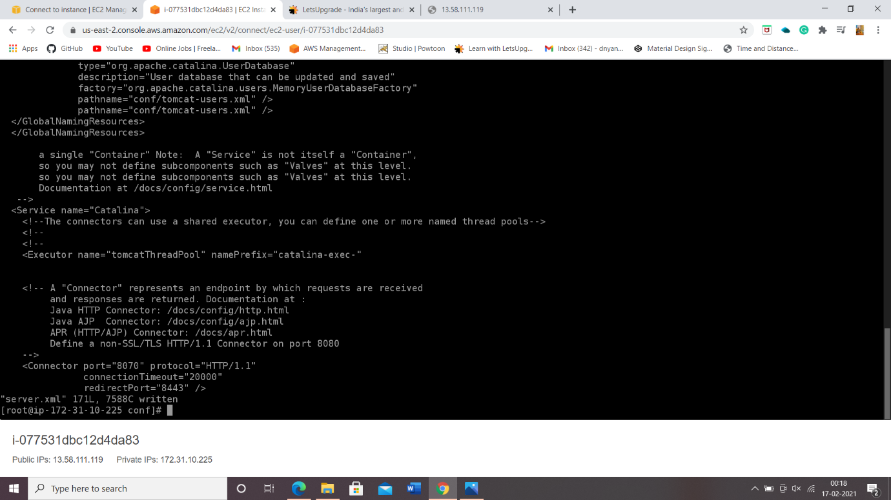

1. Now Check whether changes made reflects on browser window:

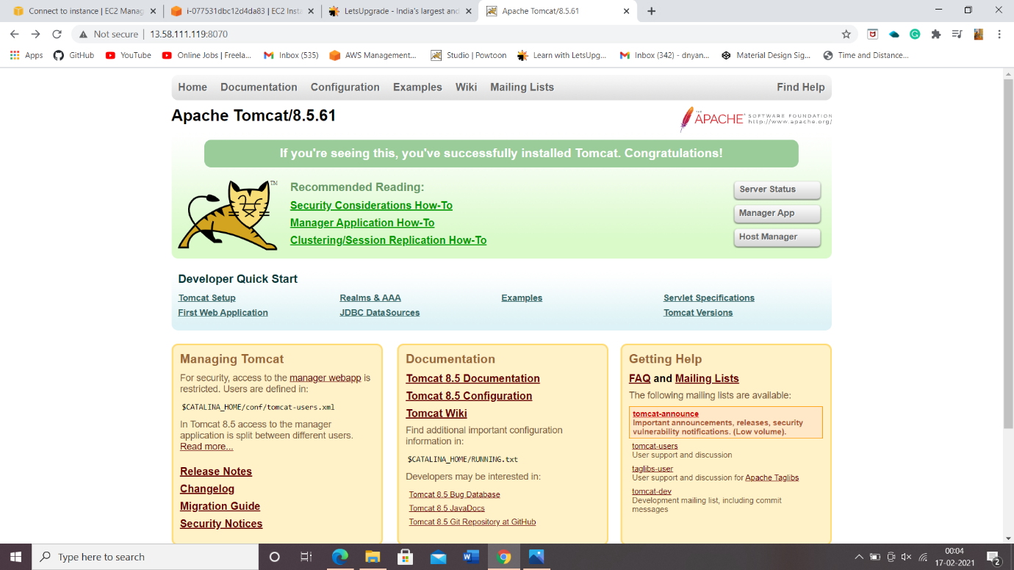

1. Editing context.xml to allow manager apps access and also adding users and roles to tomcat-users.xml:-

* In context.xml file comment Valve for both Manager App and Host Manager.
* In tomcat-users.xml file add requried roles.

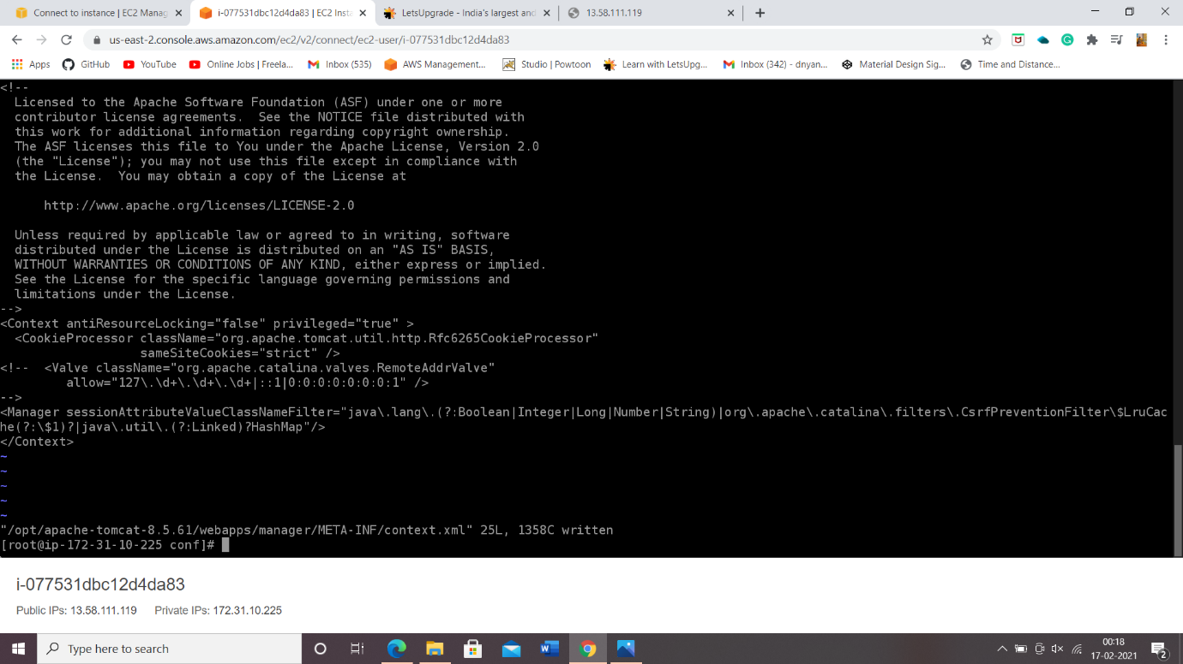

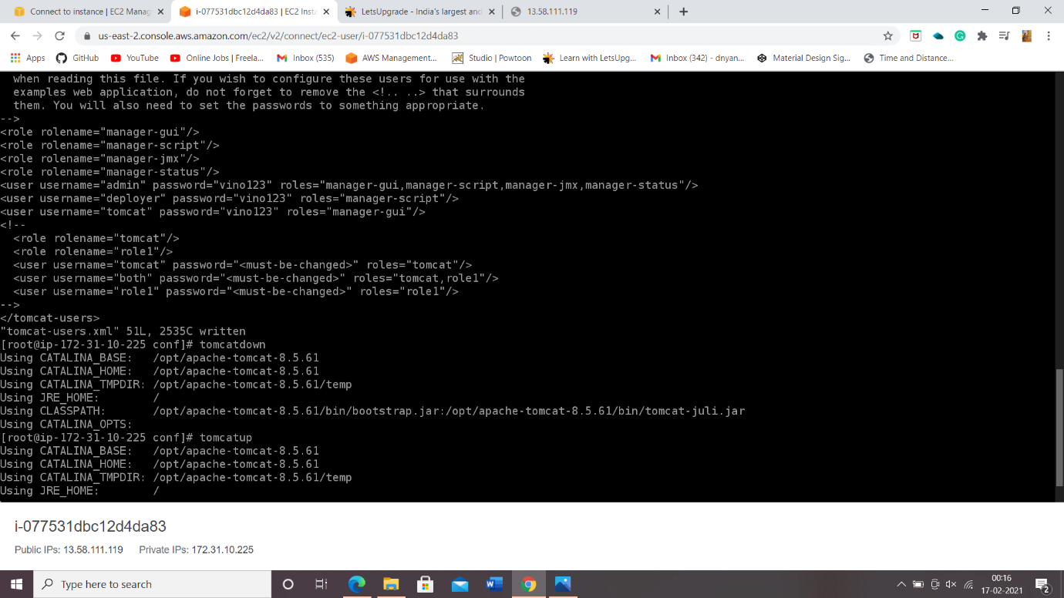

1. Now giving a ‘tomcatdown’ and ‘tomcatup’ command we restarted the application, Checking for Web Application Manager.

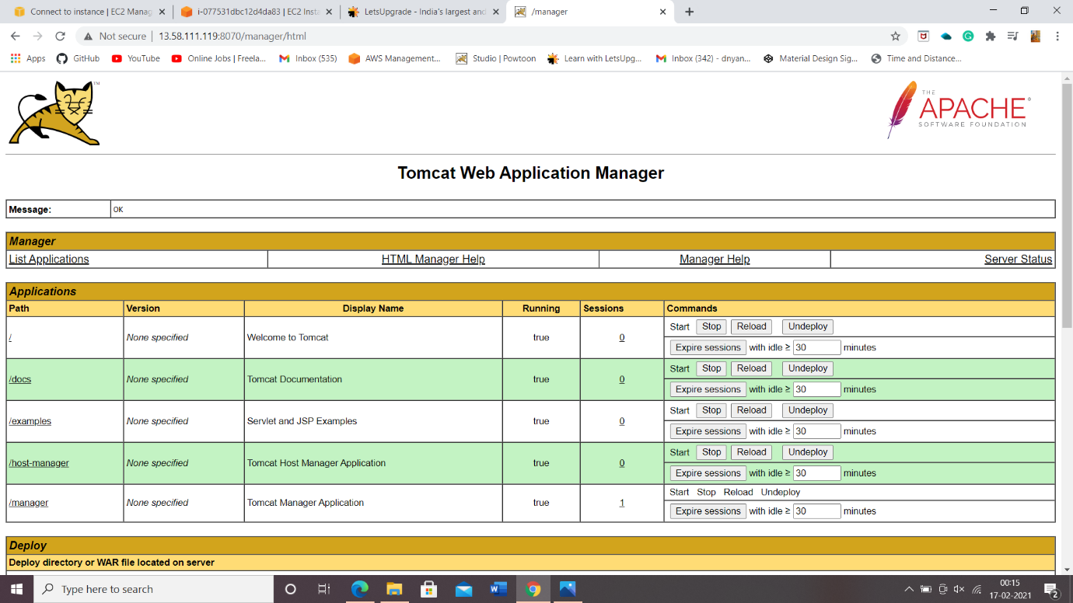

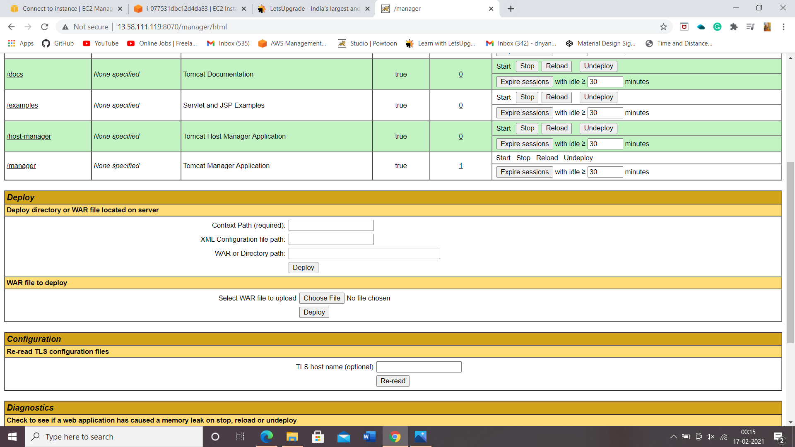

**THE END**